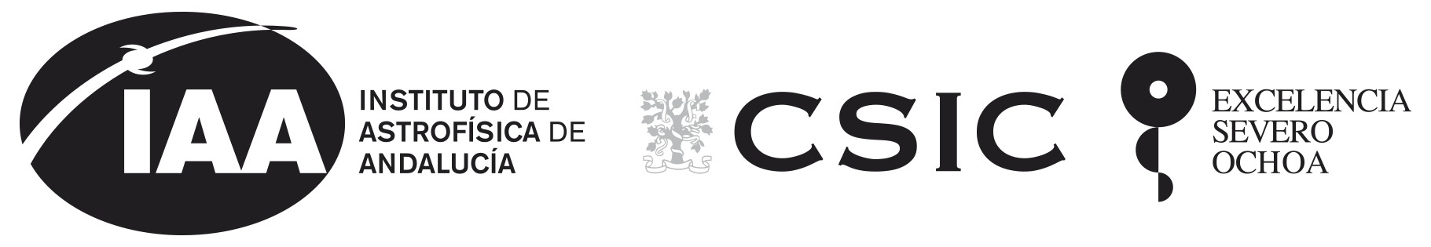
Instituto de Astrofísica de Andalucía (IAA-CSIC)
Excelencia Severo Ochoa 2018-2022
www.iaa.es

PRESS RELEASE

IAA researchers participate in GRANDMA, an international network for the study of gravitational wave sources

In 2017, the merger of two neutron stars allowed the first simultaneous study of an astronomical source in light and gravitational waves, opening a new window to the Cosmos.

The GRANDMA network coordinates 25 telescopes from all over the globe and aims at rapidly localising and analysing the counterparts of gravitational wave sources.

Granada, 16 July 2020. After centuries studying the Universe using electromagnetic waves – what we call light – the first detection of a gravitational wave in 2015 opened a new window to the Cosmos. Moreover, in 2017, the merger of two neutron stars allowed the simultaneous study of an astronomical source both in light and gravitational waves, inaugurating the multi-messenger era of astronomy. The international GRANDMA network coordinates 25 telescopes distributed around the globe, including the participation of researchers from the Institute of Astrophysics of Andalucía (IAA-CSIC), and is aimed at advancing this legacy: It works with the alerts provided by the gravitational wave observatories to localise and study the electromagnetic counterparts of the objects that produce them.

“Our research group, HETH, is one of the main nodes of GRANDMA (acronym for Global Rapid Advanced Network Devoted to the Multi-messenger Addicts). We were requested to contribute with our extended experience in the follow-up of astronomical transients and apply it to the follow-up of gravitational wave sources,” – says Christina Thöne, researcher of IAA-CSIC and leader of the HETH group. “We are very proud of being part of this truly global initiative”.

Gravitational waves allow us to study astrophysical phenomena that involve very massive objects, and their detection requires the construction of multiple instruments (interferometers) that use a combination of mirrors and lasers to measure distances with extreme precision. These interferometers, with arms extending over several kilometres, are able to detect the very subtle expansions and contractions of space-time that are induced by the passage of gravitational waves. There are currently only two observatories in the world capable of these observations, LIGO, with two stations in the United States, and Virgo, with one station in Italy, which have contributed to the detection of gravitational waves from the coalescence of black holes and neutron stars since 2015.

The third observation campaign of LIGO and Virgo, active between 2019 and 2020, has resulted in around eighty alerts that were rapidly disseminated to the scientific community, often just minutes after the detection. Although many of these detections were consistent with the merger of two black holes, a scenario in which no electromagnetic counterpart is expected, some of them did include at least one neutron star, and could hence produce an electromagnetic signal. In spite of the coordinated efforts of many research groups, no electromagnetic counterpart was identified. This could be due to the very large sky areas that needed to be covered, to the faintness of the sources, or to the fact that the objects produced no electromagnetic light at all (this is expected to depend on the type and size of the objects involved in the merger).

The follow-up work performed has, nevertheless, allowed to verify the efficiency of the GRANDMA network, coordinating its 25 telescopes and the work of researchers from 29 research institutions. The network intends to follow events producing gravitational waves in the most efficient way possible, in order to minimise the delay between the gravitational wave detection and the identification of its optical counterpart. Thanks to a solid coordination system, GRANDMA managed to follow around 90% of the LIGO/Virgo alerts (49 out of 56 candidates in this campaign) with a delay between alert and observation of less than 1.5 hrs for 50% of the cases.
"HETH employs multiple observing facilities for GRANDMA with dedicated observing proposals at Javalambre Observartory to search for the counterpart, Sierra Nevada Observatory to monitor possible host galaxies and Calar Alto telescopes as well as the Gran Telescopio Canarias for characterising candidate counterparts", says Alexander Kann, researcher at the HETH group, who is leading several of these observing proposals.

Furthermore, during this campaign, many tools were developed to optimise the follow-up process. GRANDMA is using an infrastructure dubbed ICARE (acronym for Interface and Communication for Addicts of the Rapid follow-up in the multi-messenger Era), which coordinates the follow-up strategy of all the observatories.

“We rely on machine learning to analyse the evolution of the amount of light and its colour and evaluate which of the many detected objects may be the counterpart that we are looking for,” says Sarah Antier, researcher at the Paris University that coordinates the GRANDMA network. “We can also compare these light curves with models to discard unrelated candidates. Although no viable candidate was found during this campaign, we did establish detection limits that constrain the way that these explosions (kilonovae) must have looked, since they were fainter than what we were able to detect.”

GRANDMA has also developed a citizen science programme called “Kilonova Catcher” that allows amateur astronomers to contribute to the network with their observations, with the goal of performing optical follow-up of the gravitational wave counterparts.

“GRANDMA shows how the coordinate observations by a broad and diverse network of telescopes which makes it possible to identify and understand the nature of astronomical transient sources. The network followed-up 90% of the LIGO/Virgo alerts and used its citizen science network to involve amateur astronomers in the scientific project. Now we are preparing for the next observational campaign, in which the number of alerts will increase, and we are improving the network using the lessons learned during this campaign,” concludes, Christina Thöne (IAA-CSIC).

REFERENCIAS

S. Antier et al. " GRANDMA Observations of Advanced LIGO's and Advanced Virgo's Third Observational Campaign". published in MNRAS, https://arxiv.org/abs/2004.04277

S. Antier et al. "The first six months of the Advanced LIGO's and Advanced Virgo's third observing run with GRANDMA", March 2020, MNRAS, 492, 3904

Más información:

Web GRANDMA: https://grandma.lal.in2p3.fr/

CONTACTO
Christina Thöne: cthoene@iaa.es

COMUNICACIÓN - INSTITUTO DE ASTROFÍSICA DE ANDALUCÍA:

Silbia López de Lacalle, sll@iaa.es 958230676

Manuel González García, manuelg@iaa.es 958230566

IMAGEN

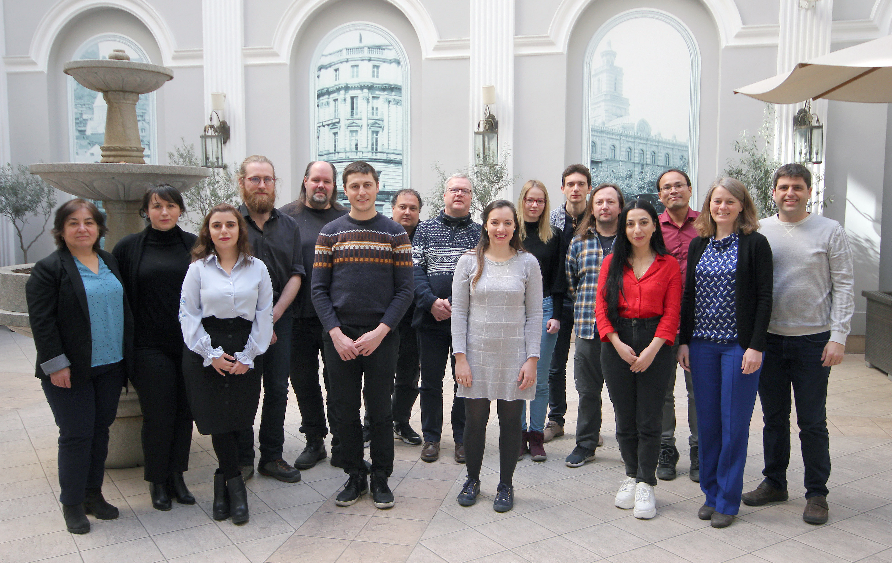

Group picture of the third GRANDMA collaboration meeting in late February in Tbilisi, Georgia, for many of us the last travel before the lockdown. The previous meeting had been held at IAA in August 2019.
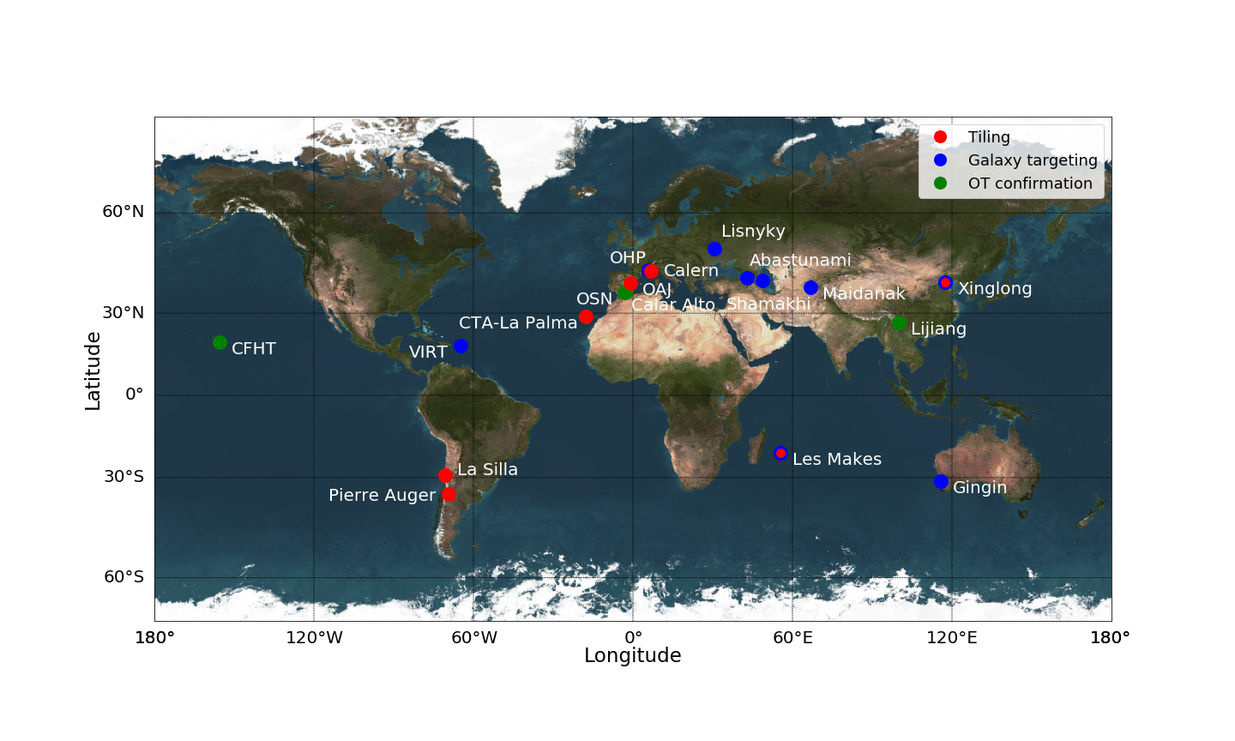
World map with the position of the different telescopes participating in the GRANDMA network with different colour dots indicating the specific follow-up they perform (observing large parts of the sky, "tiling", observing possible host galaxies, or characterise possible counterparts, "OT confirmation").

